Nicolaus Copernicus

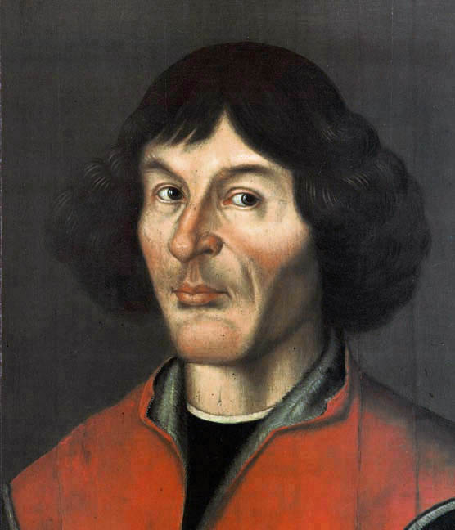

PHOTO

Date and place of birth 19 February 1473 Toruń , Kingdom of Poland

Date and place of death 24 May 1543 Frombork, Kingdom of Poland

Nationality Polish

Area in which he worked Astronomy, Canon law, Economics, mmmmmmmmmmmmmm Mathematics, Medicine

Education University of Kraków, University of Bologna, sssssssssssssssssssssssssssssUniversity of Padua, University of Ferrara

Worked in ------------------------------------------------------

Known for Heliocentrism, Copernicus' Law

Awards -------------------------------------------------------